**Buffer - bandpass filtering stage**

* **Buffer stage –** needed to impedance match the impedance of the coil with the impedance of the bandpass stage.
* **Bandpass filter –** 6th order Butterworth with ~200Hz – 2kHz.
* **DC Biaising –** voltage between 0-3.3V instead of the 0-9V currently which is the output after the bandpass stage

**Coil – detecting signal from telephone line**

* Current carrying wire of the telephone line has a magnetic field around it; if you add another parallel conductor, the first wire will induce a current in the second wire – the output of which can be seen in the oscilloscope.

**Components List**

|  |  |
| --- | --- |
| **Component name** | **Model** |
| Op-Amp | LM741 |
| Resistors (kΩ) | 180, 18, 47,56,27,220,150,39,270,220 |
| Capacitors | 2.2uF, 2.2nF, 4 x 470pF, 2 x 3.3nF |
| Wire | Single core copper wire for coil antenna |

**Problems**

* When you coil the wire, one end goes to the input of the buffer for impedance matching, however the output of the buffer is distorting the signal
  + Solution: using the bandpass filter it will get rid of all the noise frequencies
* DC Biasing needs to be accurate
  + Solution: test with POT with the correct signal on oscilloscope.
* Not having correct value components and tolerances.
  + Solution: Work with parallel/serial configurations to get the most accurate value possible.

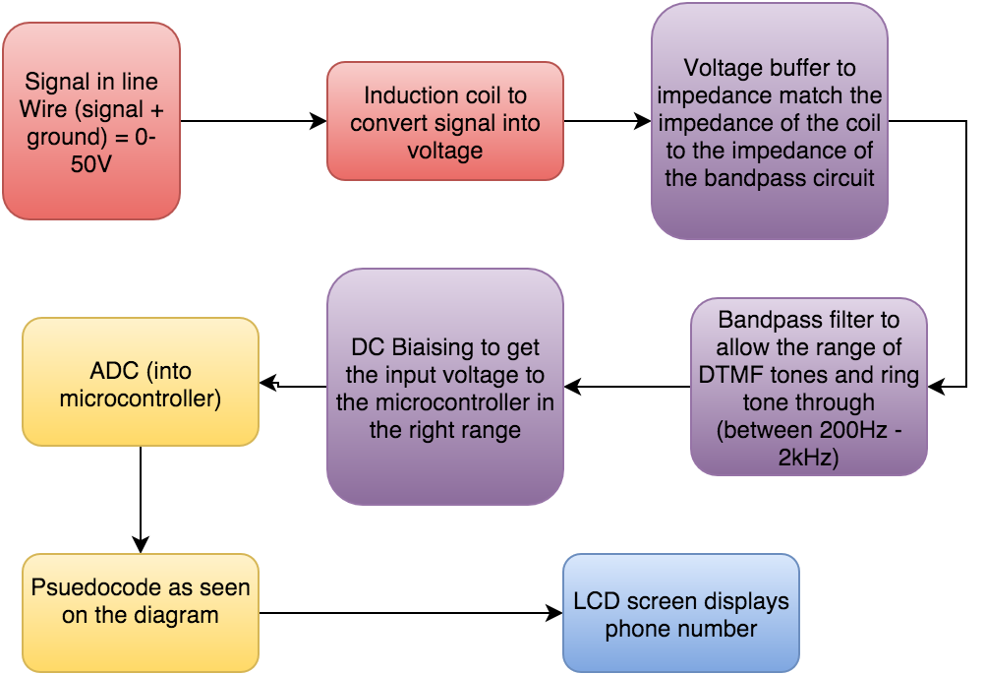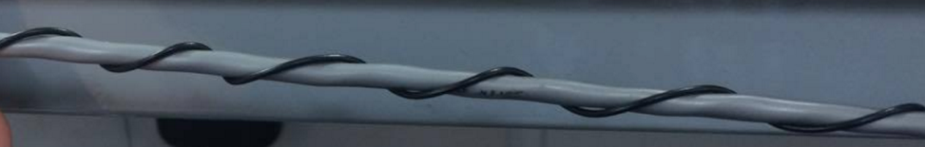

**Software (ADC – Goertzel Algorithm)**

* **ADC –** in order to compute digitally all the analog signals
* **Pseudocode:**
  + nums = { {1, 2, 3}, {4,5,6}, {7,8,9} }
  + for each frequency:
    - calculate coefficients }- Goetzel
  + 8kHz interrupt loop:
    - get ADC value
    - center around zero
    - for each frequency:
      * Q0 = xQ1 – Q2 + ADC value
      * Q2 = Q1
      * Q1 = Q0
      * mag = abs(Q12 + Q22 – Q1*Q2x)
  + if 350Hz and 440Hz; - pass dial tone
  + result = nums[highest mag x freq, highest mag y freq]
  + write to LCD